You Are Invited to
Jungle Land Playground*

SATURDAY, November 20th FROM 10:00 AM TO 12:00 PM
________________________Birthday Party”
RSVP: by ________________at Tel. ____________________

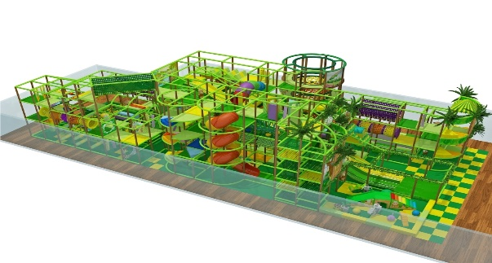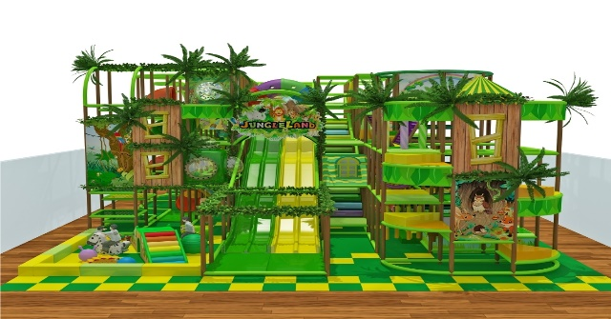
Our Address: 1033 Edgeley Blvd., Unit 2, Concord, ON, L4K 5Z4
*Socks-Only, Nut-Free Facility - Parents Must Supervise Their Kids at All Times

